**Project Title: Paws and Pixels: A Transfer Learning Expedition into Bear Classification**

**Project Description:**

Paws and Pixels" is an innovative project focused on leveraging transfer learning techniques to classifydifferent bear species based on images. The project aims to develop a robust deep learning model that can accurately identify bears from images, contributing to wildlife conservation efforts and promoting coexistence with these magnificent creatures. The project will utilize pre-trained models and transfer learning approaches to overcome challenges posed by limited labeled data for specific bear species.

By harnessing pre-trained neural networks and adapting them to the unique characteristics of bear species, this expedition aims to enhance wildlife monitoring and conservation efforts. The project integrates advancements in computer vision and machine learning to create a user-friendly tool that aids researchers, wildlife enthusiasts, and conservationists in accurately identifying and tracking bears in their natural habitats..

Through the fusion of cutting-edge technology and ecological conservation, "Paws and Pixels" addresses the critical need for automated and precise bear classification. The project not only contributes to the understanding of bear populations but also fosters a deeper appreciation for the intersection of technology and wildlife conservation. By democratizing the ability to identify and monitor bear species, the expedition aspires to empower a wider audience to actively participate in preserving these magnificent creatures and their habitats. "Paws and Pixels" represents a significant stride towards the harmonious coexistence of technology and the natural world, showcasing the potential of artificial intelligence in safeguarding our planet's biodiversity.

**Technical Architecture:**

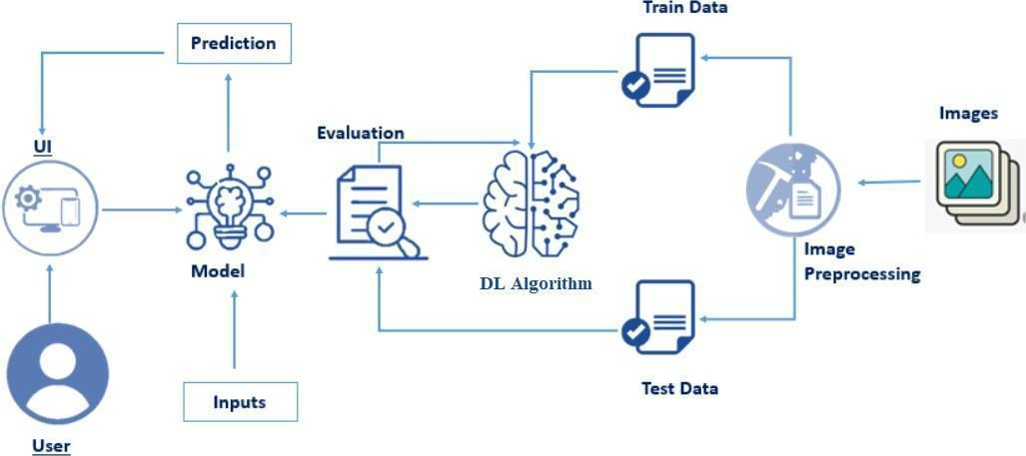

**Prerequisites:**

**To complete this project, you must require the following software’s, concepts and packages**

* **Anaconda navigator and PyCharm / Spyder:**
* Refer the link below to download anaconda navigator
* Link (PyCharm) : <https://youtu.be/1ra4zH2G4o0>
* Link (Spyder) : <https://youtu.be/5mDYijMfSzs>
* **Python packages:**
* Open anaconda prompt as administrator
* Type “pip install numpy” and click enter.
* Type “pip install pandas” and click enter..
* Type “pip install tensorflow==2.3.2” and click enter.
* Type “pip install keras==2.3.1” and click enter.
* Type “pip install Flask” and click enter.

**Prior Knowledge:**

You must have prior knowledge of following topics to complete this project.

* **Deep Learning Concepts**
* **VGG16:** <https://datagen.tech/guides/computer-vision/vgg16/>
* **Inception-V3:** <https://iq.opengenus.org/inception-v3-model-architecture/>
  + Convolutional Neural Networks (CNNs): [https://www.analyticsvidhya.com/blog/2021/05/convolutional-neural-networks-cnn/ s://www.javatpoint.com/k-nearest-neighbor-algorithm-for-machine-learning](https://www.analyticsvidhya.com/blog/2021/05/convolutional-neural-networks-cnn/%20s://www.javatpoint.com/k-nearest-neighbor-algorithm-for-machine-learning)
  + Over fitting and Regularization: [https://www.analyticsvidhya.com/blog/2021/07/prevent-overfitting-using-regularization-techniques/](https://www.analyticsvidhya.com/blog/2021/07/prevent-overfitting-using-regularization-techniques/%20)
  + Optimizers: [https://www.analyticsvidhya.com/blog/2021/10/a-comprehensive-guide-on-deep-learning-optimizers/](https://www.analyticsvidhya.com/blog/2021/10/a-comprehensive-guide-on-deep-learning-optimizers/%20ttps://www.analyticsvidhya.com/blog/2019/08/11-important-model-evaluation-error-metrics/)
* **Flask:** Flask is a popular Python web framework, meaning it is a third-party Python library used for developing web applications.

Link: [**https://www.youtube.com/watch?v=lj4I_CvBnt0**](https://www.youtube.com/watch?v=lj4I_CvBnt0)

**Project Objectives:**

By the end of this project you’ll understand:

●       Preprocessing  the images.

●       Applying Transfer learning algorithms on the dataset.

●       How deep neural networks detect the disease.

●       You will be able to know how to find the accuracy of the model.

●       You will be able to Build web applications using the Flask framework.

**Project Flow:**

* The user interacts with the UI (User Interface) to choose the image.
* The chosen image analyzed by the model which is integrated with flask application.
* The Model analyzes the image, then the prediction is showcased on the Flask UI.

To accomplish this, we have to complete all the activities and tasks listed below

* Data Collection.
* Create a Train and Test path.
* Data Pre-processing.
* Import the required library
* Configure ImageDataGenerator class
* ApplyImageDataGenerator functionality to Trainset and Testset
* Model Building
* Pre-trained CNN model as a Feature Extractor
* Adding Dense Layer
* Configure the Learning Process
* Train the model
* Save the Model
* Test the model
* Application Building
* Create an HTML file
* Build Python Code

**Project Structure:**

Create a Project folder which contains files as shown below

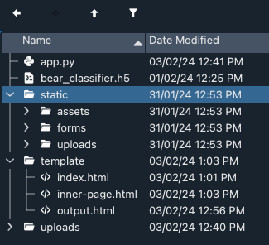

* The Data folder contains the training and testing images for training our model.
* We are building a Flask Application that needs HTML pages stored in the **templates.**
* folder and a python script **app.py** for server-side scripting
* we need the model which is saved and the saved model in this content is a **bear_classifier.h5**
* templates folder contains index.html, predict.html & output.html pages.

**Milestone 1: Data Collection**

  There are many popular open sources for collecting the data. Eg: kaggle.com, UCI repository, etc.

**Activity 1: Download the dataset**

It is most crucial aspect that makes algorithm training possible. So this section allows you to download the required dataset.

There are many popular open sources for collecting the data. Eg: kaggle.com, UCI repository, etc.

In this project we have used water_potability.csv data. This data is downloaded from kaggle.com. Please refer the link given below to download the dataset.

Link: <https://www.kaggle.com/datasets/gwongz/bears-4>

As the dataset is downloaded. Let us read and understand the data properly with the help of some visualization techniques and some analysing techniques.

Note: There are a number of techniques for understanding the data. But here we have used some of it. In an additional way, you can use multiple techniques

   We are going to build our training model on Google colab.

Upload the dataset into google drive and connect the google colab with drive using the below code

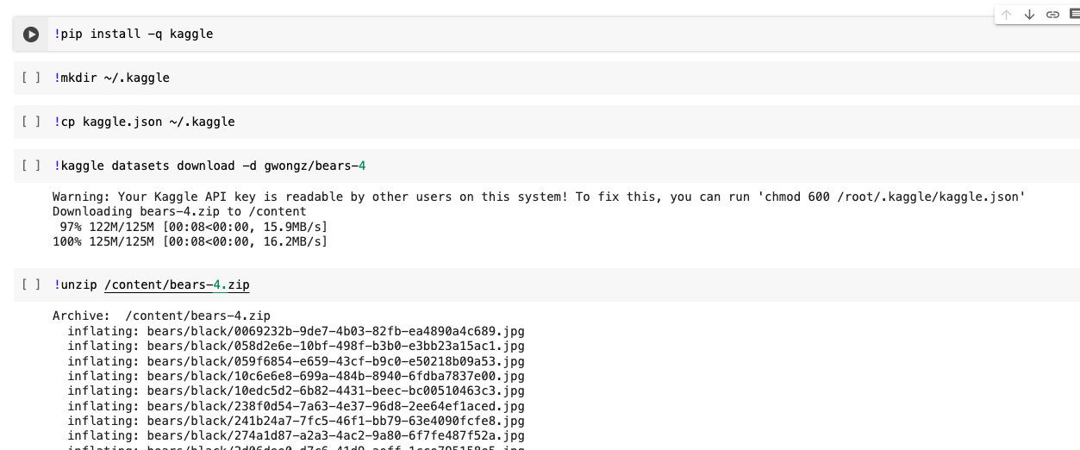

**Activity 2: Create training and testing dataset**

To build a DL model we have six classes in our dataset. But In the project dataset folder training and testing data are needed. So, in this case we just have to assign a variable and pass the folder path to it.

Three different transfer learning models are used in our project and the best model  is selected.

The image input size of model is 64,64.

**Milestone 2: Image Preprocessing**

In this milestone we will be improving the image data that suppresses unwilling distortions or enhances some image features important for further processing, although perform some geometric transformations of images like rotation, scaling, translation, etc.

**Activity 1: Importing the libraries**

Import the necessary libraries as shown in the image

.

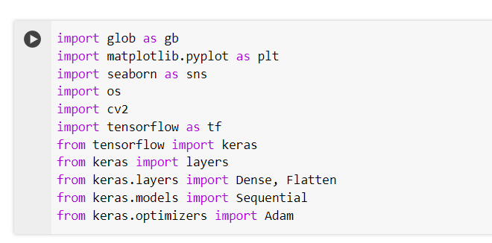

**Activity 2: Configure ImageDataGenerator class**

ImageDataGenerator class is instantiated and the configuration for the types of data augmentation

There are five main types of data augmentation techniques for image data; specifically:

* Image shifts via the width_shift_range and height_shift_range arguments.
* The image flips via the horizontal_flip and vertical_flip arguments.
* Image rotations via the rotation_range argument
* Image brightness via the brightness_range argument.
* Image zoom via the zoom_range argument.

An instance of the ImageDataGenerator class can be constructed for train and test.

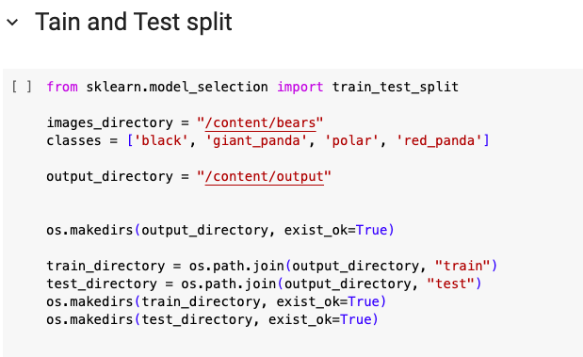

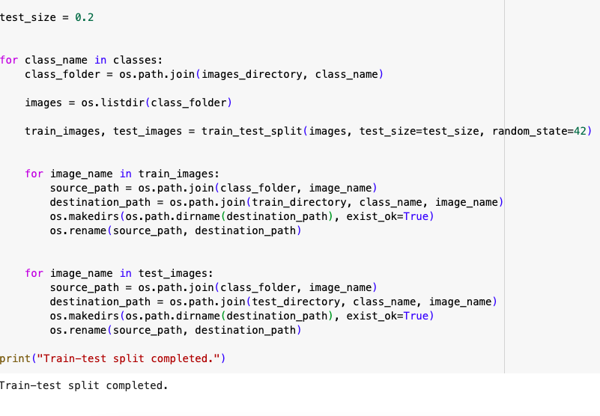

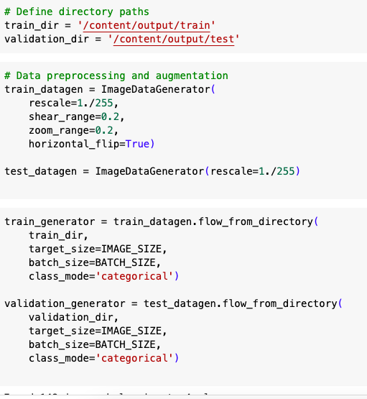

**Activity 3: Apply ImageDataGenerator functionality to Training_data and Validation_data**

Let us apply ImageDataGenerator functionality to the Training_data and Validation_data by using the following code. For Training set keras.preprocessing.image_dataset_from_directory function.

This function will return batches of images from the subdirectories

Arguments:

* directory: Directory where the data is located. If labels are "inferred", it should contain subdirectories, each containing images for a class. Otherwise, the directory structure is ignored.
* batch_size: Size of the batches of data which is  16.
* target_size: Size to resize images after they are read from disk.
* class_mode:

-  ‘int': means that the labels are encoded as integers (e.g. for sparse_categorical_crossentropy loss).

- 'categorical' means that the labels are encoded as a categorical vector (e.g. for categorical_crossentropy loss).

- 'binary' means that the labels (there can be only 2) are encoded as float32 scalars with values 0 or 1 (e.g. for binary_crossentropy).

 - None (no labels).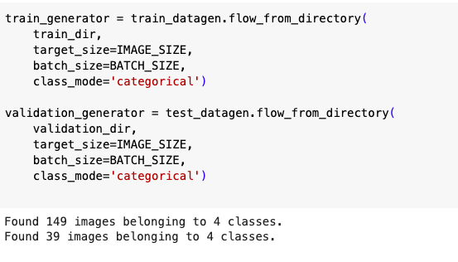

**Milestone 3: Model Building**

Now it's time to build our model. Let’s use the pre-trained model  VGG16 one of the convolution neural net (CNN) architecture which is considered as a very good model for Image classification.

Deep understanding on the  model – Link is referred to in the prior knowledge section. Kindly refer to it before starting the model building part.

**Activity 1: Pre-trained CNN model as a Feature Extractor**

For one of the models, we will use it as a simple feature extractor by freezing all the five convolution blocks to make sure their weights don’t get updated after each epoch as we train our own model.

Here, we have considered images of dimension (224,224,3).

 Also, we have assigned include_top = False because we are using convolution layer for features extraction and wants to train fully connected layer for our images classification(since it is not the part of Imagenet dataset)

Flatten layer flattens the input. Does not affect the batch size.

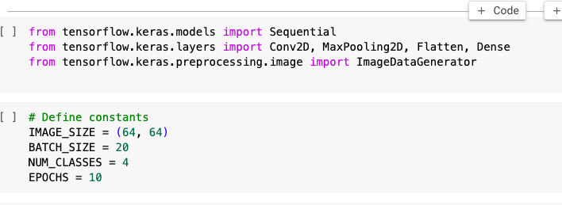

**Activity 2: Adding Dense Layers**

A dense layer is a deeply connected neural network layer. It is the most common and frequently used layer.

The number of neurons in the Dense layer is the same as the number of classes in the training set. The neurons in the last Dense layer, use Softmax activation to convert their outputs into respective probabilities.

Understanding the model is a very important phase to properly use it for training and prediction purposes. Keras provides a simple method, summary to get the full information about the model and its layers.

**Activity 3: Configure the Learning Process**

The compilation is the final step in creating a model. Once the compilation is done, we can move on to the training phase. The loss function is used to find errors or deviations in the learning process. Keras requires a loss function during the model compilation process.

Optimization is an important process that optimizes the input weights by comparing the prediction and the loss function. Here we are using adam optimizer

Metrics are used to evaluate the performance of your model. It is similar to the loss function, but not used in the training process

**Activity 4: Train the model**

Now, let us train our model with our image dataset. The model is trained for 25 epochs and after every epoch, the current model state is saved if the model has the least loss encountered till that time. We can see that the training loss decreases in almost every epoch till 10 epochs and probably there is further scope to improve the model.

**fit_generator** functions used to train a deep learning neural network

**Arguments:**

* steps_per_epoch: it specifies the total number of steps taken from the generator as soon as one epoch is finished and the next epoch has started. We can calculate the value of     steps_per_epoch as the total number of samples in your dataset divided by the batch size.

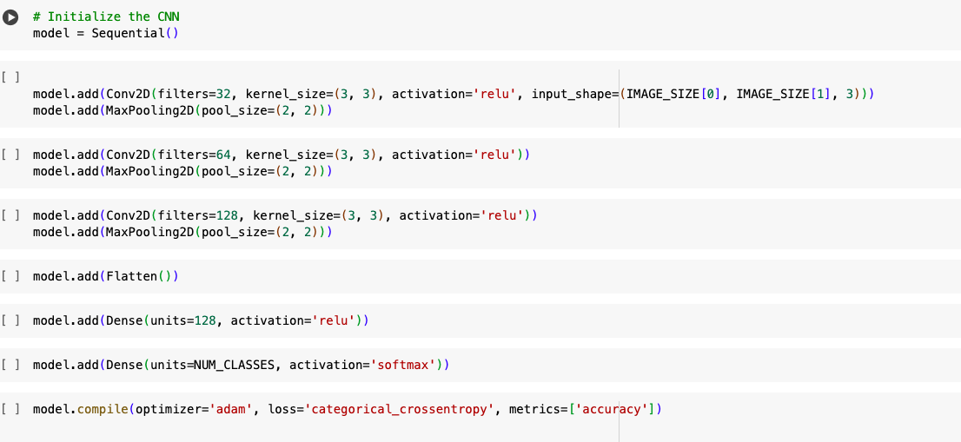

* Epochs: an integer and number of epochs we want to train our model for.
* validation_data can be either:

                      - an inputs and targets list

                      - a generator

                      - an inputs, targets, and sample_weights list which can be used to evaluate

                        the loss and metrics for any model after any epoch has ended.

* validation_steps: only if the validation_data is a generator then only this argument

can be used. It specifies the total number of steps taken from the generator before it is

stopped at every epoch and its value is calculated as the total number of validation data points

in your dataset divided by the validation batch size.

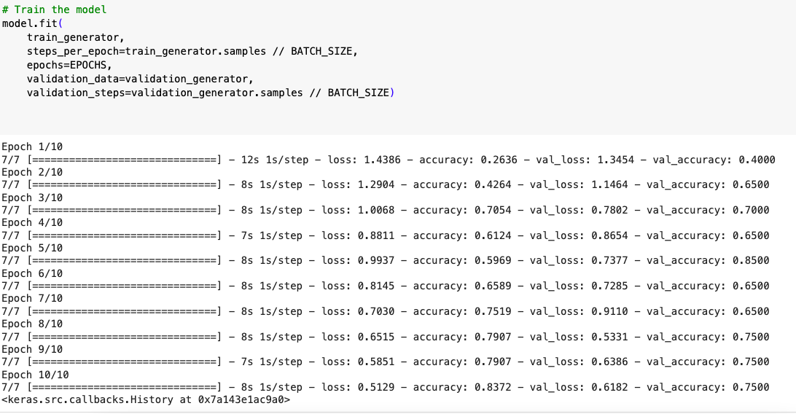

From the above run time, we can easily observe that at 18 epoch the model is giving the better accuracy.

**Activity 5 : VGG16**

Now it's time to build our  second model. Let’s use the pre-trained model vgg16 one of the convolution neural net (CNN) architecture which is considered as a very good model for Image classification.

Deep understanding on the  model – Link is referred to in the prior knowledge section. Kindly refer to it before starting the model building part.

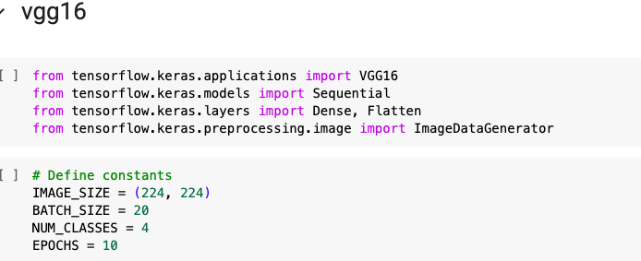

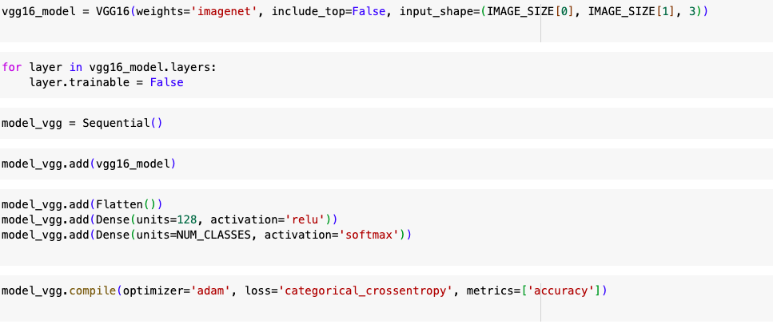

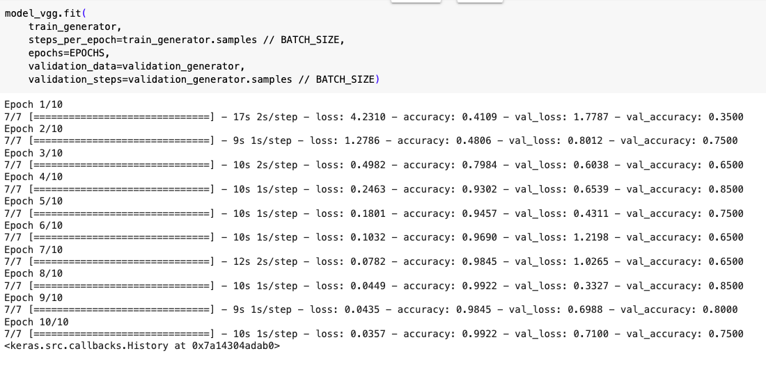

**Activity 6 : Inception**

Now it's time to build our  second model. Let’s use the pre-trained model InceptionV3 one of the convolution neural net (CNN) architecture which is considered as a very good model for Image classification.

Deep understanding on the  model – Link is referred to in the prior knowledge section. Kindly refer to it before starting the model building part.

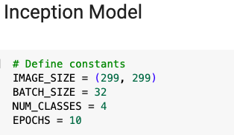

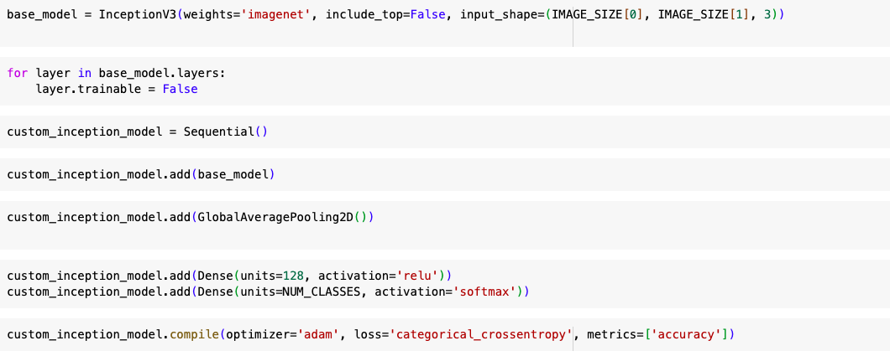

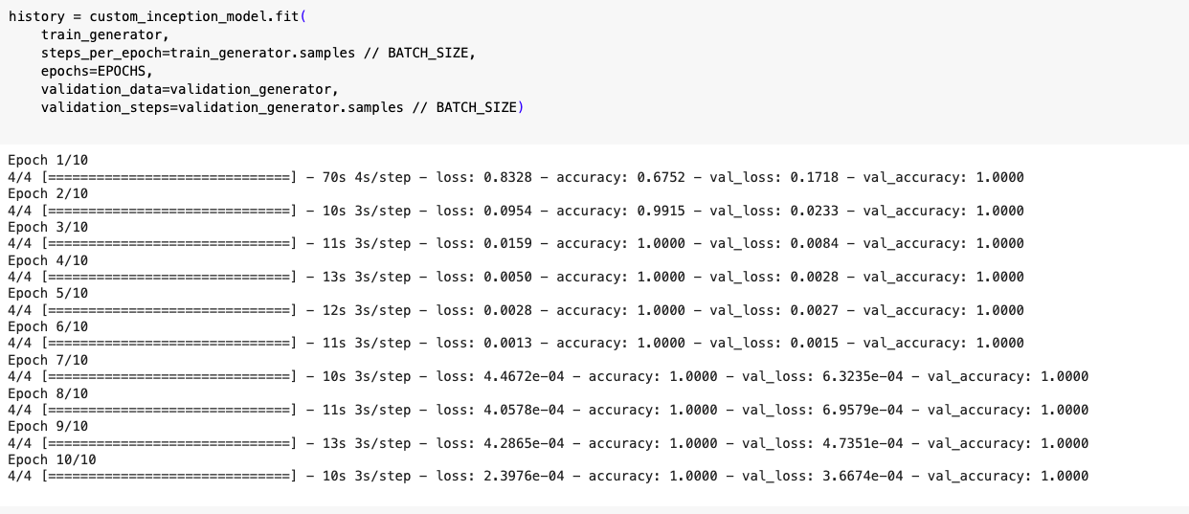

**Activity 8 : Testing the Model**

Model testing is the process of evaluating the performance of a deep learning model on a dataset that it has not seen before. It is a crucial step in the development of any machine learning model, as it helps to determine how well the model can generalize to new data.

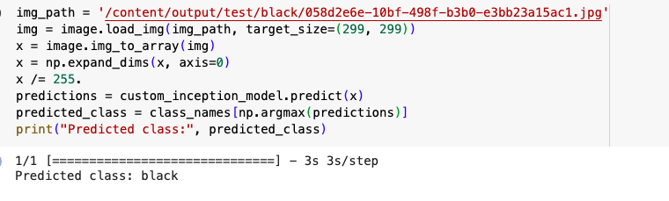

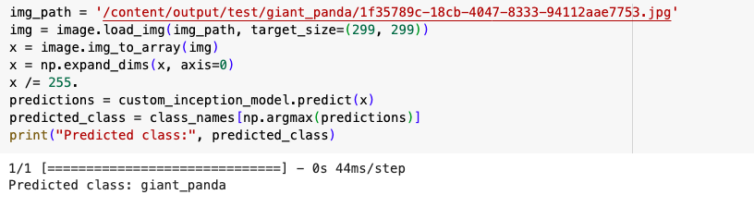

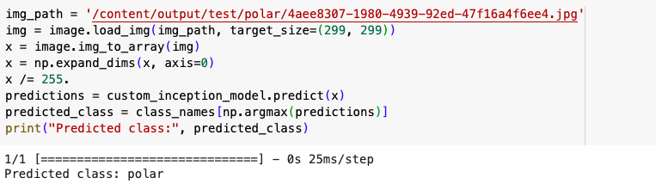

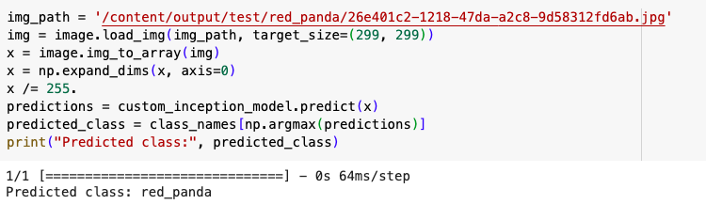

* In the above code, we have tested the model with a image of vehicle.

**Milestone 4: Save the Model**

The model is saved with .h5 extension as follows

An H5 file is a data file saved in the Hierarchical Data Format (HDF). It contains multidimensional arrays of scientific data.

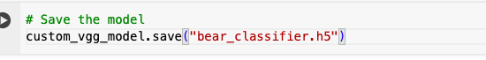

**Milestone 5: Application Building**

In this section, we will be building a web application that is integrated to the model we built. A UI is provided for the uses where he has to enter the values for predictions. The enter values are given to the saved model and prediction is showcased on the UI.

This section has the following tasks

* Building HTML Pages
* Building server side script

**Activity1: Building Html Pages:**

For this project create one HTML file namely

* Index.html

Let’s see how our index.html page looks like:

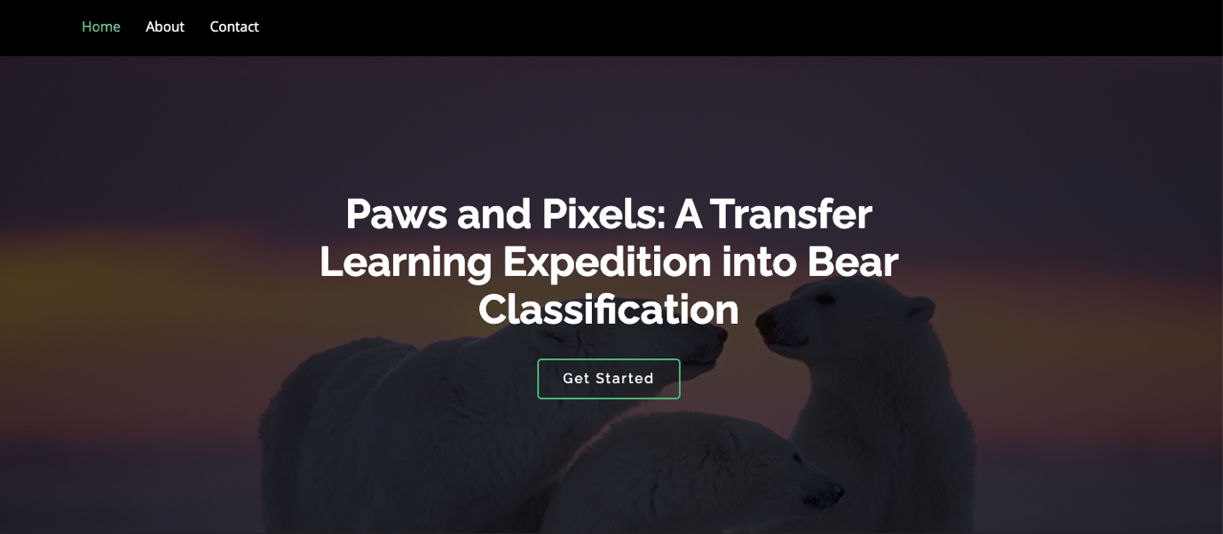

When you click on about button on the top , you will be redirecting to the following page

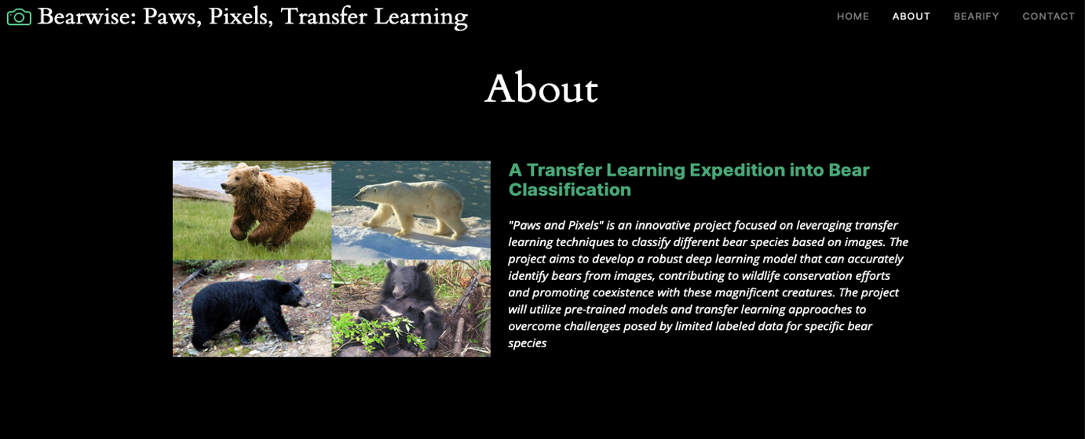

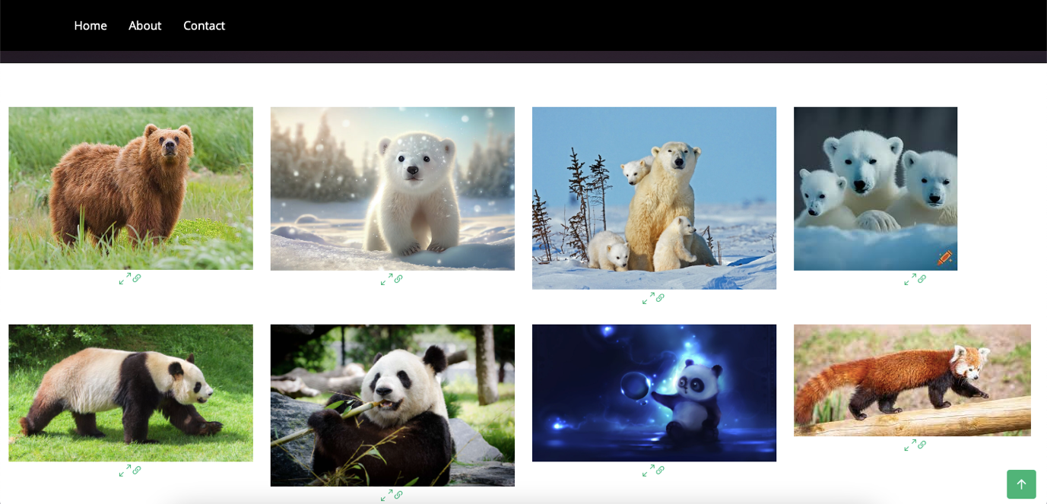

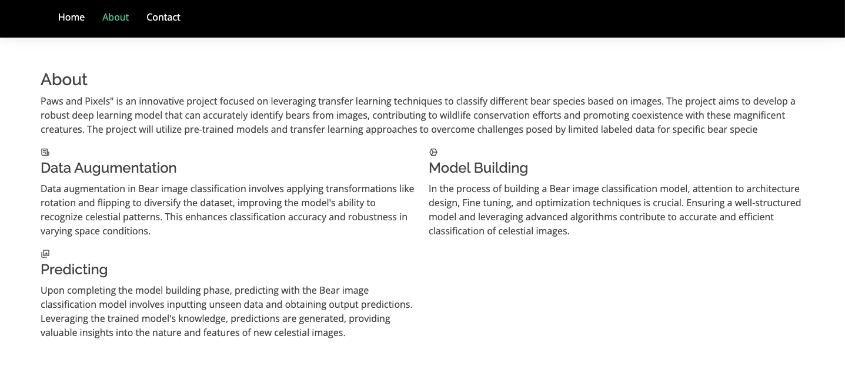

**Activity 2: Build Python code:**

* Import the libraries
* Loading the saved model and initializing the flask app
* Render HTML pages:
* Once we uploaded the file into the app, then verifying the file uploaded properly or not.Here we will be using declared constructor to route to the HTML page which we have created earlier.
* In the above example, ‘/’ URL is bound with home.html function. Hence, when the home page of the web server is opened in browser, the html page will be rendered. Whenever you enter the values from the html page the values can be retrieved using POST Method.

Here we are routing our app to res function. This function retrieves all the values from the HTML page using Post request. That is stored in an array. This array is passed to the model.predict() function. This function returns the prediction. And this prediction value will rendered to the text that we have mentioned in the index.html page earlier.

**Activity 3: Run the application**

* Open the Anaconda prompt from the start menu.
* Navigate to the folder where your Python script is.
* Now type the “python app.py” command.
* Navigate to the localhost where you can view your web page.
* Click on the predict button from the top right corner, enter the inputs, click on the submit button, and see the result/prediction on the web.

Click on Get Started at top right corner to go to inner page as below: 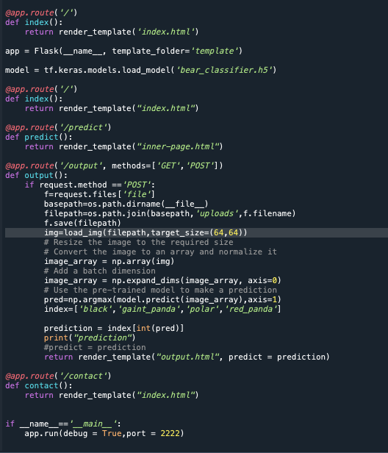

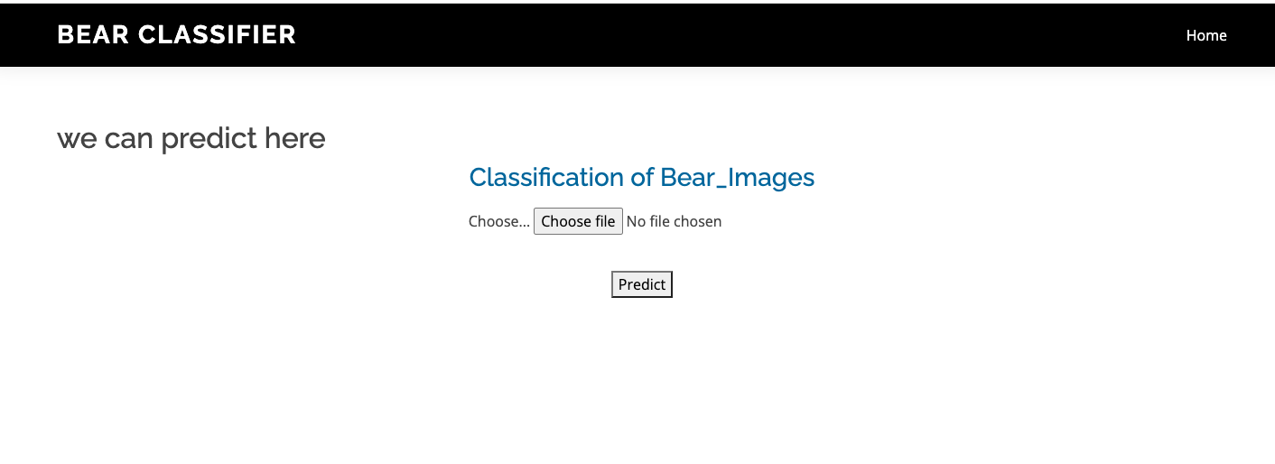

click on predict button

Input 1:

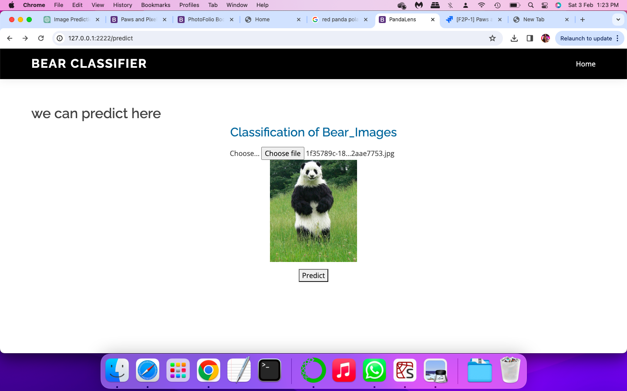

Once you upload the image and click on predict button, the output will be displayed in the below page

Output:1

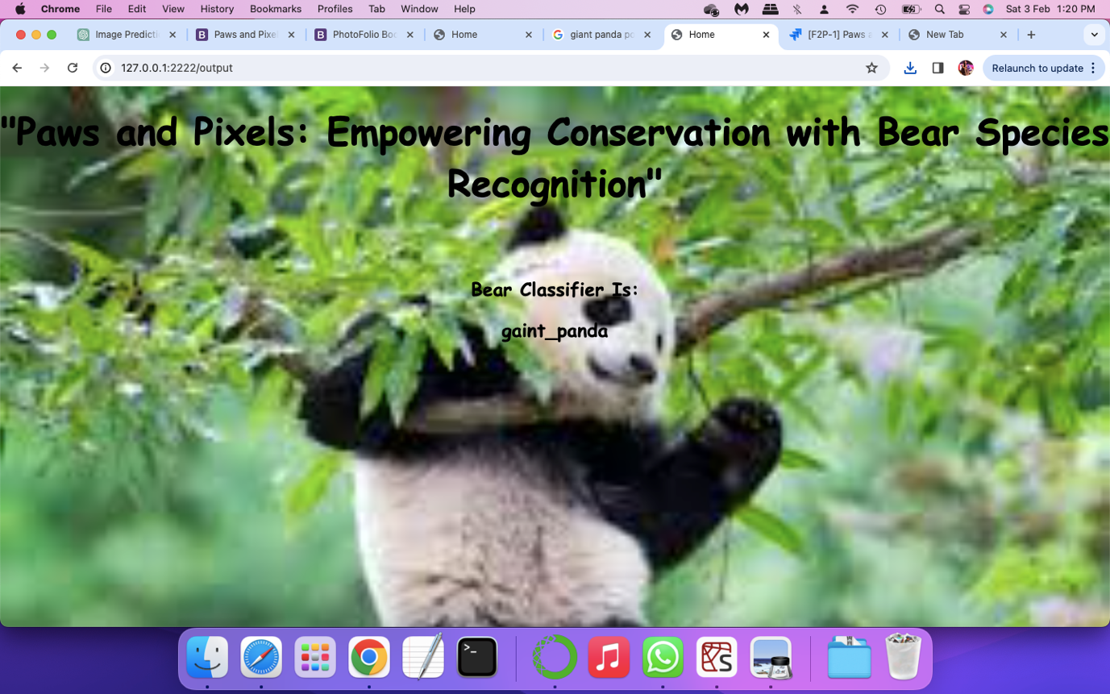

Input:2

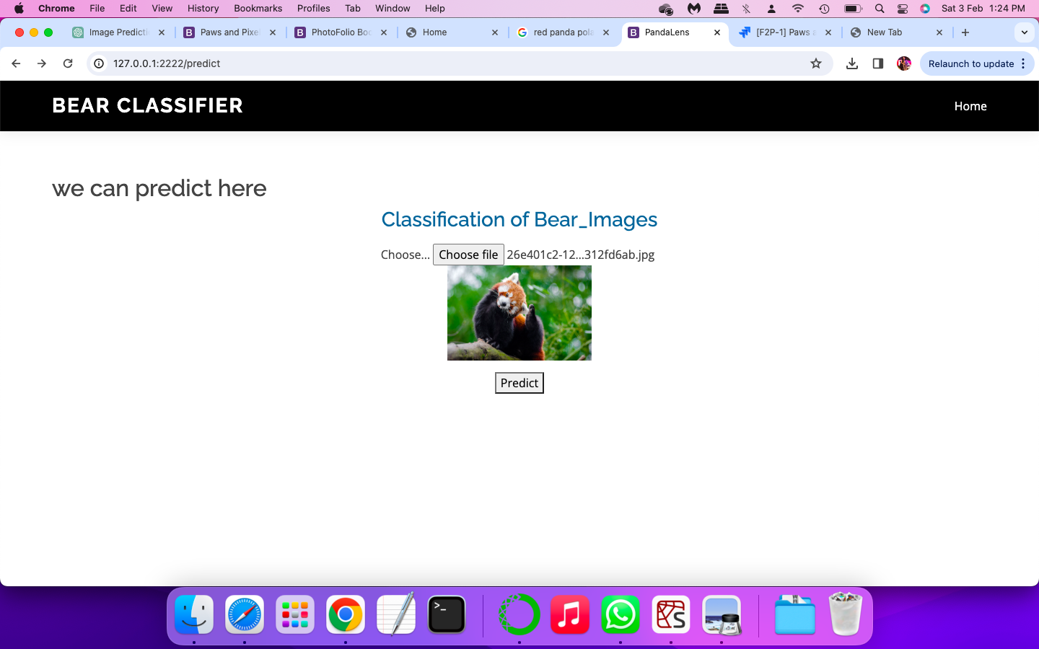

Output:2

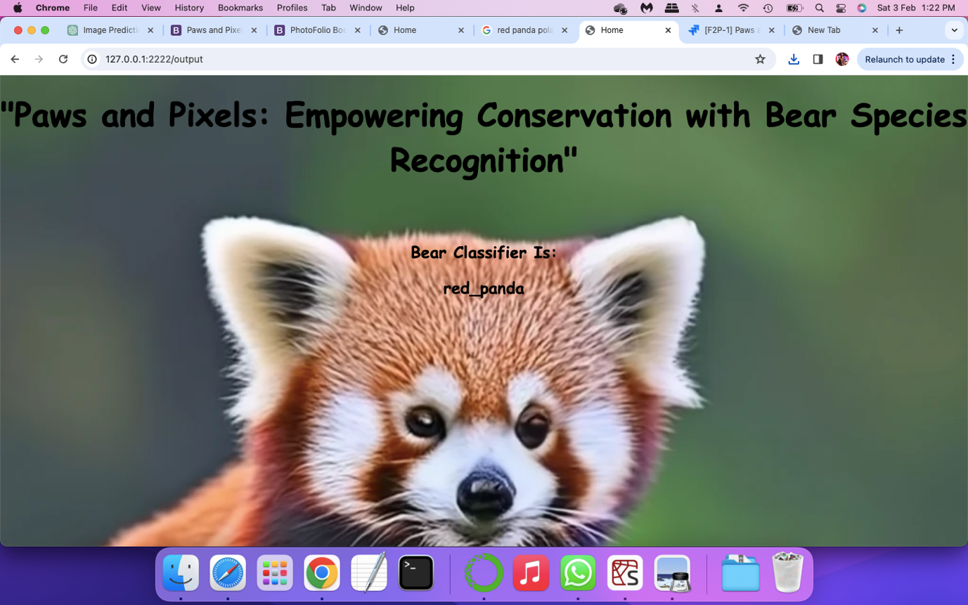

Input 3:

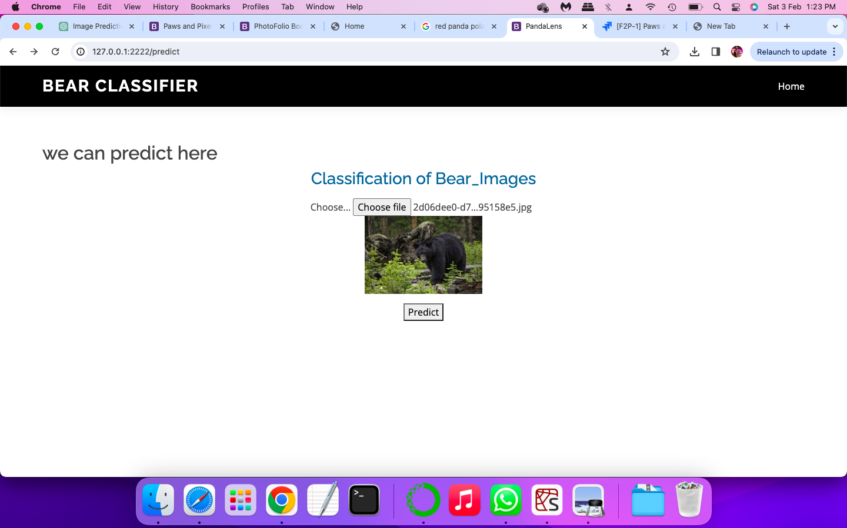

Output 3:

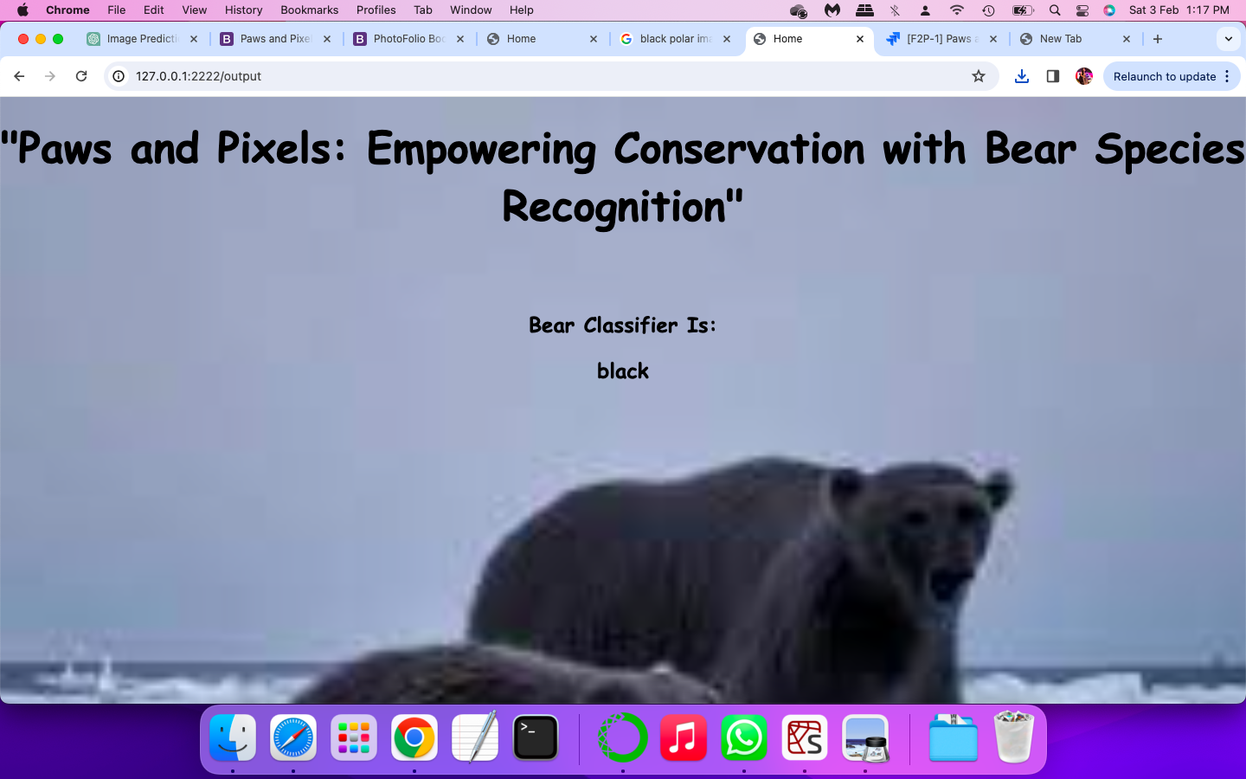

Input 4:

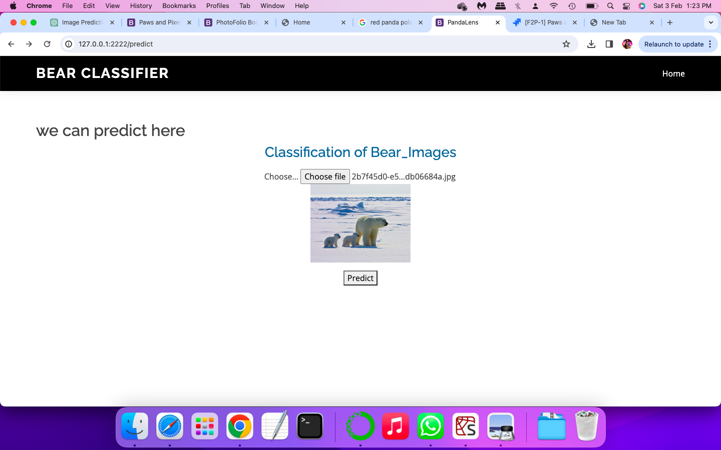

Output 4:

